**COAL LAB 3**

**Question 1**

TITLE Declaration (Declaration.asm)

INCLUDE Irvine32.inc

.data

val1 SWORD ?

val2 SBYTE -10

.code

main PROC

MOVZX eax,val1

MOVZX ebx,val2

call DumpRegs

exit

main ENDP

END main

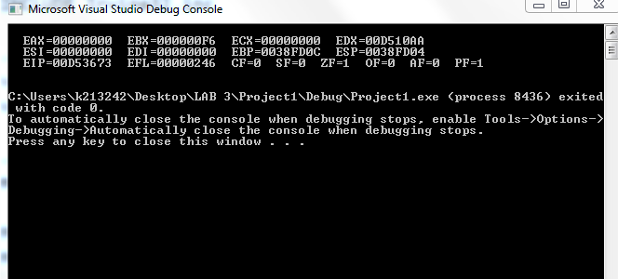

**Question 2**

TITLE Initialization (Initialization.asm)

INCLUDE Irvine32.inc

.data

val3 SDWORD -2147483647

.code

main PROC

MOV eax, val3

call DumpRegs

exit

main ENDP

END main

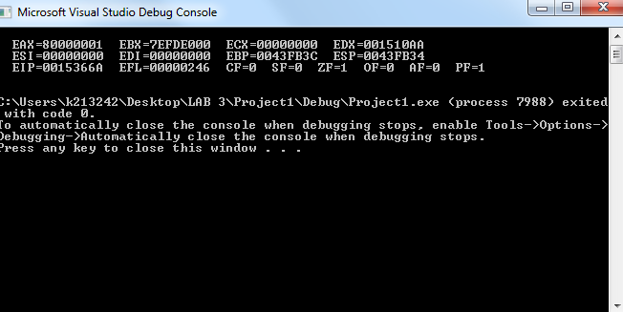

**Question 3**

TITLE Question_3 (Question_3.asm)

INCLUDE Irvine32.inc

.data

wArray WORD 1,2,3

.code

main PROC

MOVZX eax,wArray

MOVZX ebx,[wArray + 2]

MOVZX ecx,[wArray + 4]

call DumpRegs

exit

main ENDP

END main 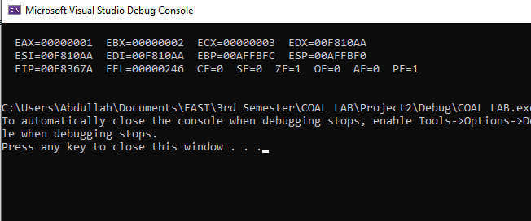

**Question 4**

Include Irvine32.inc

.data

Color BYTE "RED", 0

var1 WORD 12

var2 WORD 2

var3 WORD 13

var4 WORD 8

var5 WORD 14

.code

main PROC

call DumpRegs

exit

main ENDP

end main

**Question 5**

Include irvine32.inc

.data

a SWORD 10h

b SWORD 15h

e SWORD 20h

d SWORD 30h

.code

main PROC

MOVZX eax, a

MOVZX ebx, b

ADD eax, ebx

MOV ecx, eax ; ecx = a+b

MOVZX eax, a

SUB eax, ebx

MOV edx, eax ; edx = a-b

SUB ecx, edx; ; ecx = (a+b) - (a-b)

MOVZX eax, e

ADD ecx, eax

MOVZX eax, d

ADD ecx, eax

call DumpRegs

exit

main ENDP

end main

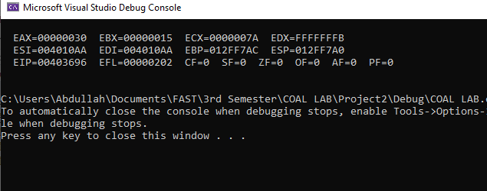

**Question 6**

Include irvine32.inc

.data

a DWORD 00010000b

b DWORD 00010101b

e DWORD 00100000b

d DWORD 00110000b

.code

main PROC

MOV eax, a

ADD eax, b

MOV ebx, a

SUB ebx, b

SUB eax, ebx

ADD eax, e

ADD eax, d

MOV ebx, eax

CALL DumpRegs

exit

main ENDP

END main

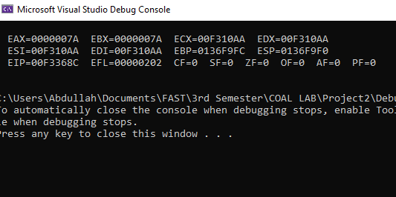

**Question 7**

Include Irvine32.inc

.data

Imm8 = 20

Data1 WORD 8

Data2 WORD 15

Data3 WORD 20

.code

main PROC

MOV eax, Imm8

MOVZX ebx, Data1

ADD eax, ebx

ADD eax, Imm8

MOVZX ebx, Data2

ADD eax, ebx

MOVZX ebx, Data3

SUB eax, ebx

CALL DumpRegs

exit

main ENDP

end main

